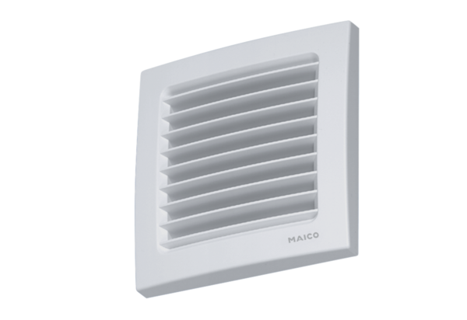Internal grille, adjustable AZE 100Packing unit: 1 pieceRange: K
Article number: 0059.0959Manufacturer: MAICO

