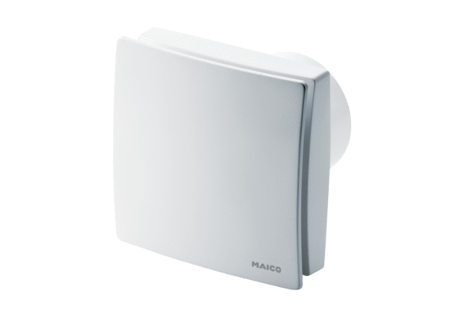Small room fan ECA 150 ipro VZCPacking unit: 1 pieceRange: A
Article number: 0084.0086Manufacturer: MAICO

