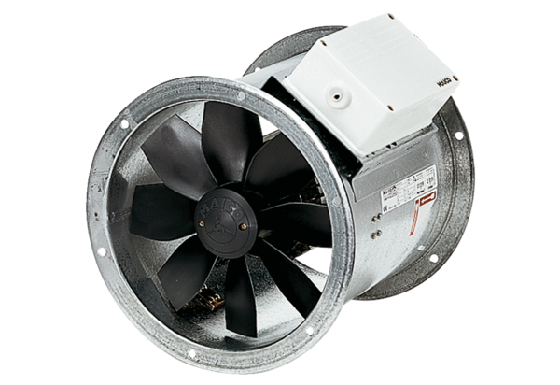Axial duct fan DZR 40/6 BPacking unit: 1 pieceRange: C
Article number: 0086.0029Manufacturer: MAICO

