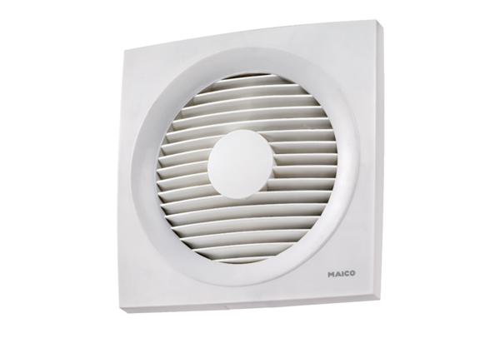Axial wall-mounted fan EN 20Packing unit: 1 pieceRange: C
Article number: 0081.0307Manufacturer: MAICO

