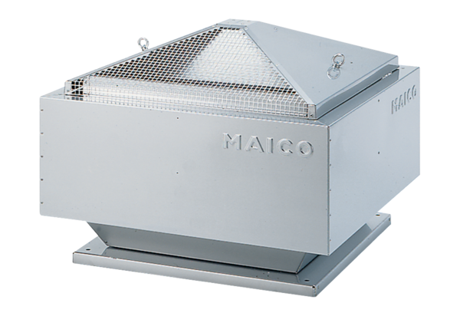Centrifugal roof fan GRD 25Packing unit: 1 pieceRange: C
Article number: 0087.0017Manufacturer: MAICO

