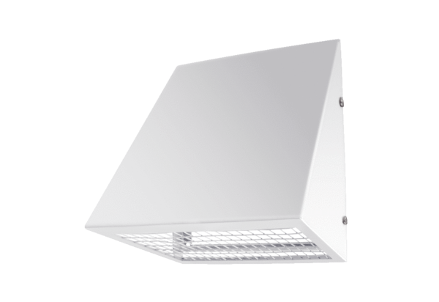Outside air wall connection KW-AL 12WPacking unit: 1 pieceRange: K
Article number: 0152.0074Manufacturer: MAICO

