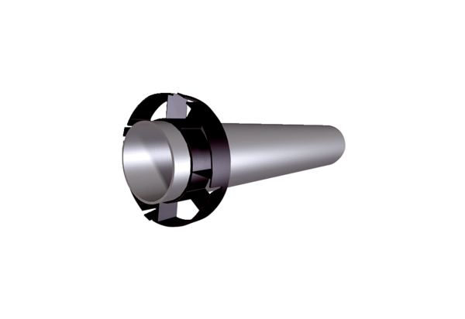Extension kit PPB 30 VSDFPacking unit: 1 pieceRange: K
Article number: 0059.0870Manufacturer: MAICO

