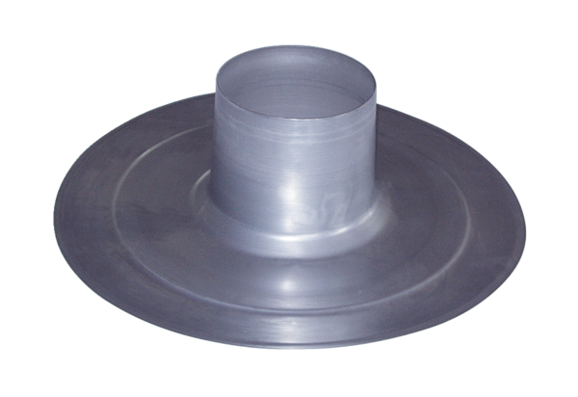Roofing tile DP 160 APacking unit: 1 pieceRange: B
Article number: 0092.0383Manufacturer: MAICO

