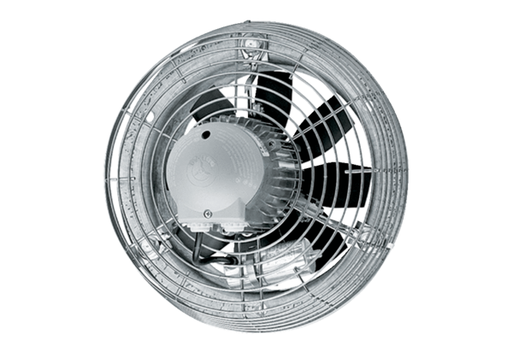Axial wall fan EZS 35/4 BPacking unit: 1 pieceRange: C
Article number: 0094.0007Manufacturer: MAICO

