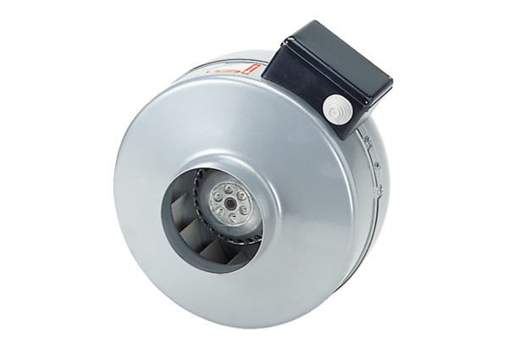Centrifugal duct fan ERR 20/1 NPacking unit: 1 pieceRange: E
Article number: 0080.0868Manufacturer: MAICO

