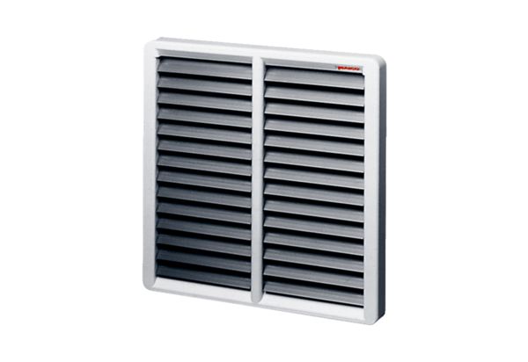Shutter, manual RS 50Packing unit: 1 pieceRange: C
Article number: 0151.0344Manufacturer: MAICO

