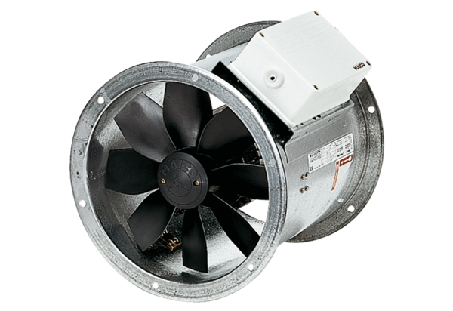Axial duct fan DZR 30/6 BPacking unit: 1 pieceRange: C
Article number: 0086.0023Manufacturer: MAICO

