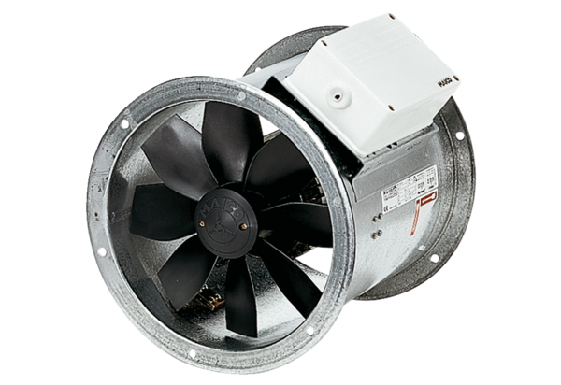Axial duct fan EZR 35/4 BPacking unit: 1 pieceRange: C
Article number: 0086.0007Manufacturer: MAICO

