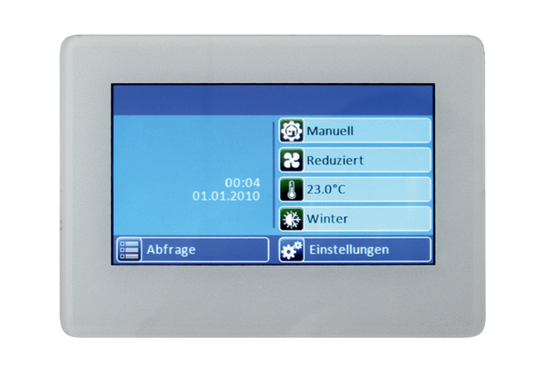Room air control RLS T1 WSPacking unit: 1 pieceRange: K
Article number: 0157.0835Manufacturer: MAICO

