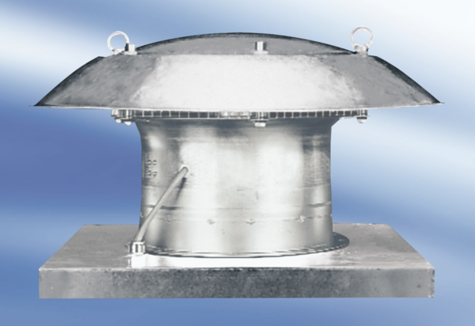Axial roof fan DZD 25/42 APacking unit: 1 pieceRange:
Article number: 0087.0431Manufacturer: MAICO

