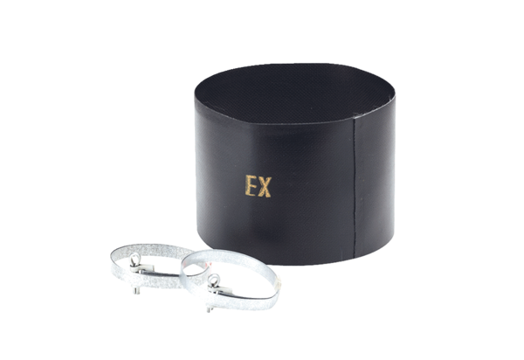Flexible cuff ELM 18 ExPacking unit: 1 pieceRange: C
Article number: 0092.0245Manufacturer: MAICO

