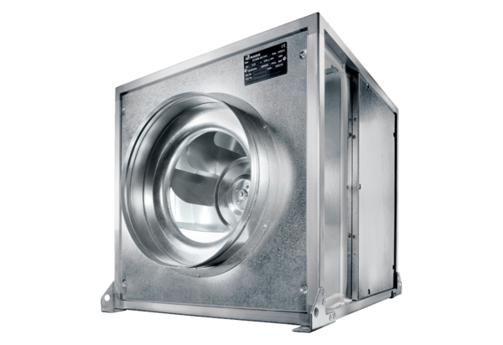Quickbox DSQ 40/4 KPacking unit: 1 pieceRange: C
Article number: 0080.0077Manufacturer: MAICO

