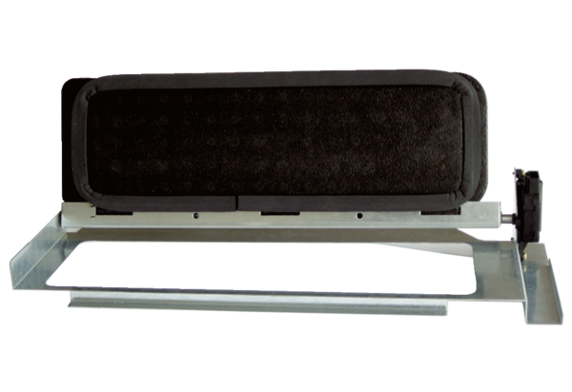Bypass for heat exchanger WS-BP 320/470Packing unit: 1 pieceRange: K
Article number: 0093.1265Manufacturer: MAICO

