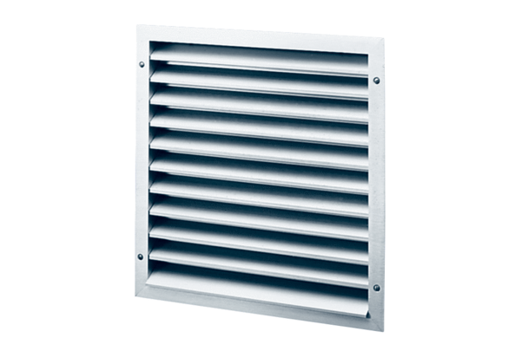External grille MLZ 35Packing unit: 1 pieceRange: C
Article number: 0151.0104Manufacturer: MAICO

