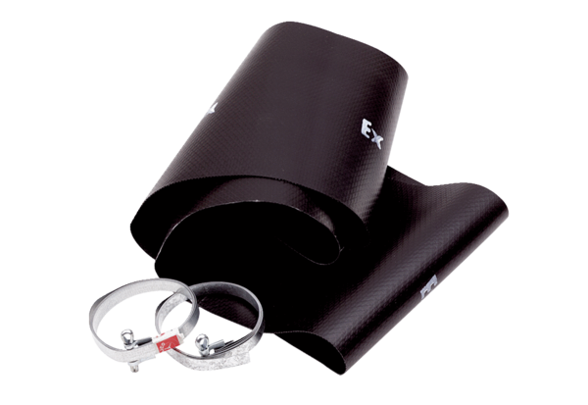Flexible cuff EL 45 ExPacking unit: 1 pieceRange: C
Article number: 0092.0236Manufacturer: MAICO

