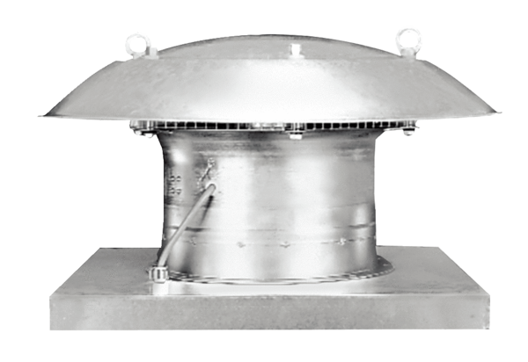Axial roof fan DZD 40/4 BPacking unit: 1 pieceRange: C
Article number: 0087.0222Manufacturer: MAICO

