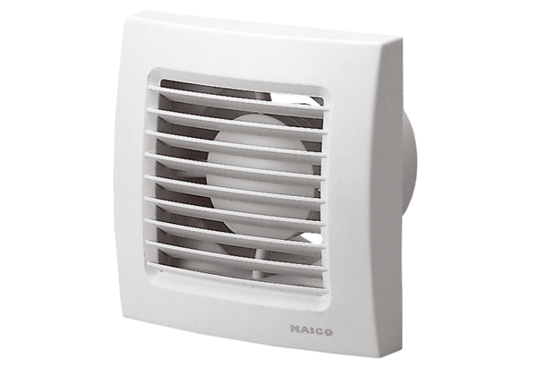Small room fan ECA 120Packing unit: 1 pieceRange: A
Article number: 0084.0006Manufacturer: MAICO

