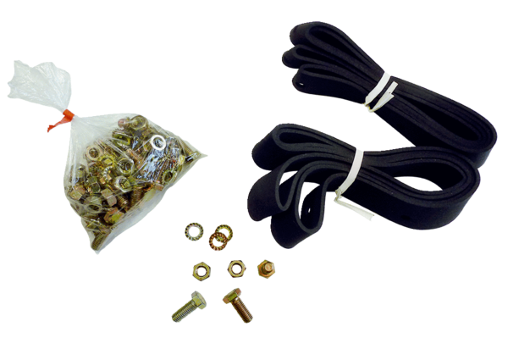Mounting and sealing material BD 60Packing unit: 1 pieceRange: C
Article number: 0092.0139Manufacturer: MAICO

