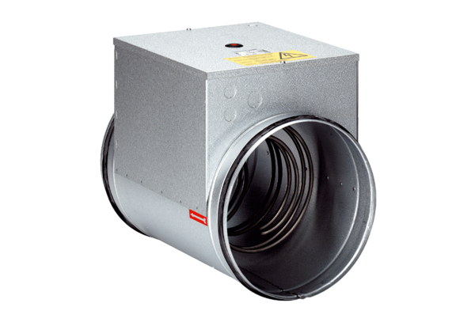Electrical air heater ERH 10-04Packing unit: 1 pieceRange: C
Article number: 0082.0100Manufacturer: MAICO

