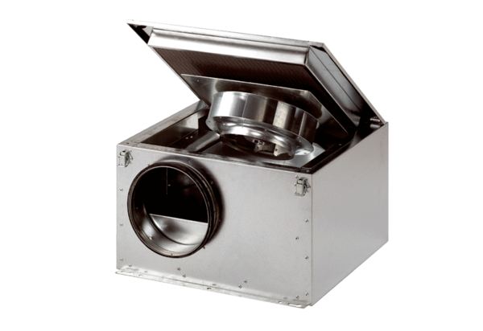Sound-insulated ventilation box ESR 25 SPacking unit: 1 pieceRange: C
Article number: 0080.0230Manufacturer: MAICO

