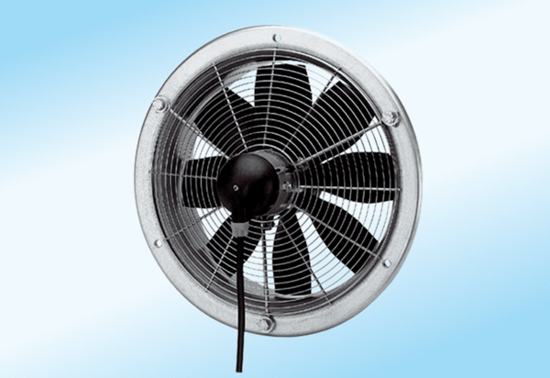Axial wall fan DZS 40/6 A-ExPacking unit: 1 pieceRange: C
Article number: 0094.0111Manufacturer: MAICO

