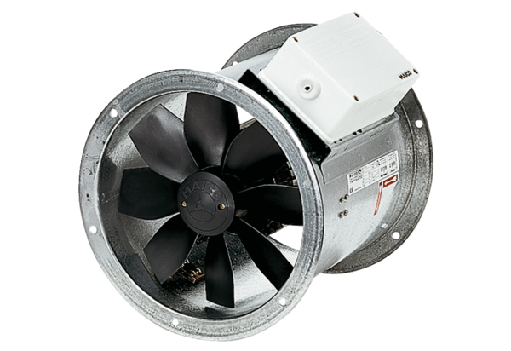Axial duct fan EZR 50/8 BPacking unit: 1 pieceRange: C
Article number: 0086.0012Manufacturer: MAICO

