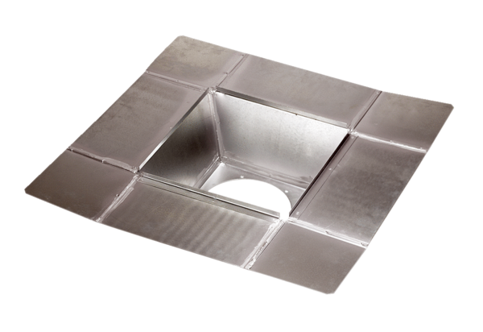Intermediate socket SZ 25Packing unit: 1 pieceRange: C
Article number: 0092.0288Manufacturer: MAICO

