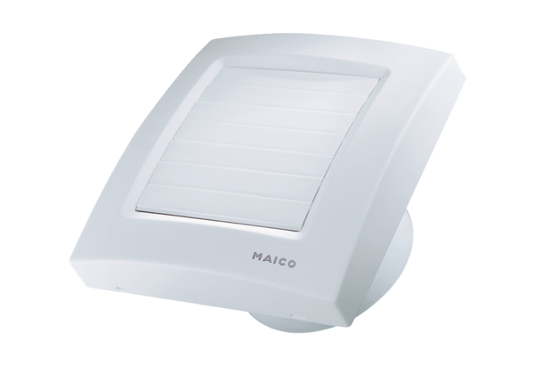Small room fan ECA 150 KFPacking unit: 1 pieceRange: A
Article number: 0084.0017Manufacturer: MAICO

