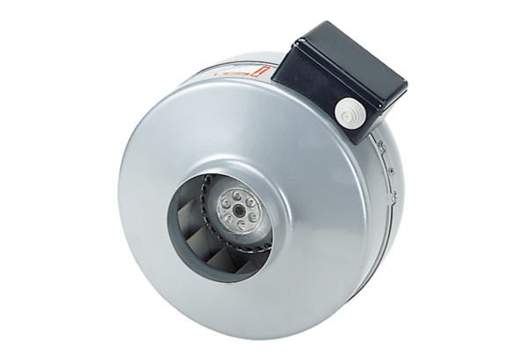Centrifugal duct fan ERR 20/1 SPacking unit: 1 pieceRange: C
Article number: 0080.0276Manufacturer: MAICO

