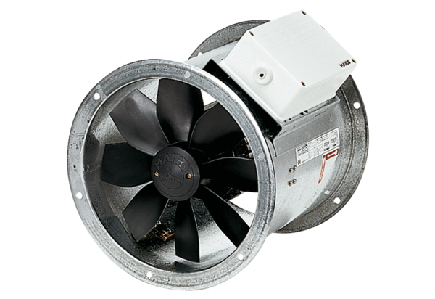Axial duct fan DZR 60/4 BPacking unit: 1 pieceRange: C
Article number: 0086.0039Manufacturer: MAICO

