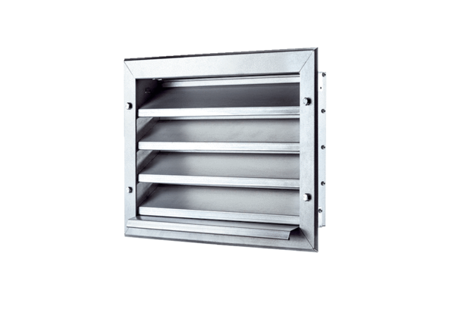External grille LZP 22Packing unit: 1 pieceRange: D
Article number: 0151.0255Manufacturer: MAICO

