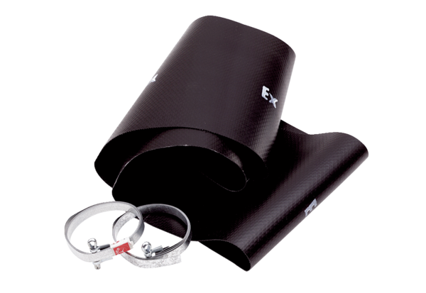Flexible cuff EL 30 ExPacking unit: 1 pieceRange: C
Article number: 0092.0233Manufacturer: MAICO

