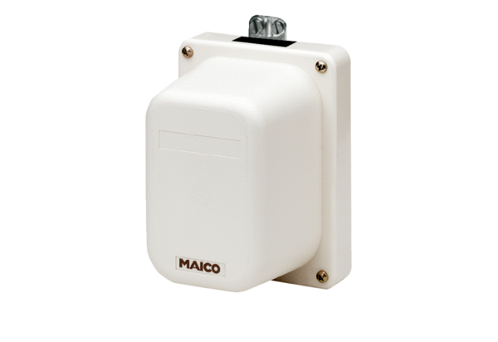Servomotor MS 2Packing unit: 1 pieceRange: C
Article number: 0093.0403Manufacturer: MAICO

