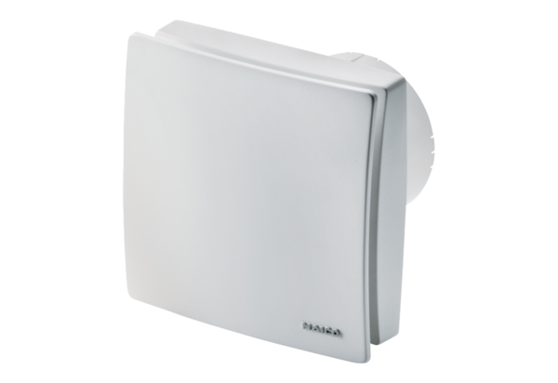Small room fan ECA 100 ipro KHPacking unit: 1 pieceRange: A
Article number: 0084.0208Manufacturer: MAICO

