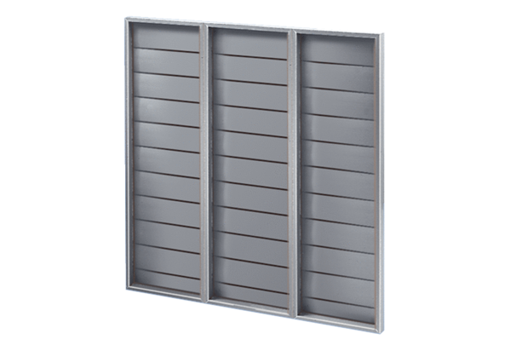Shutter ARP 80Packing unit: 1 pieceRange: C
Article number: 0151.0081Manufacturer: MAICO

