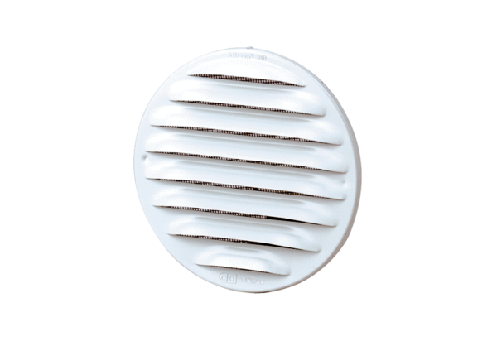External grille MGR 80/125 aluPacking unit: 1 pieceRange: K
Article number: 0078.0033Manufacturer: MAICO

