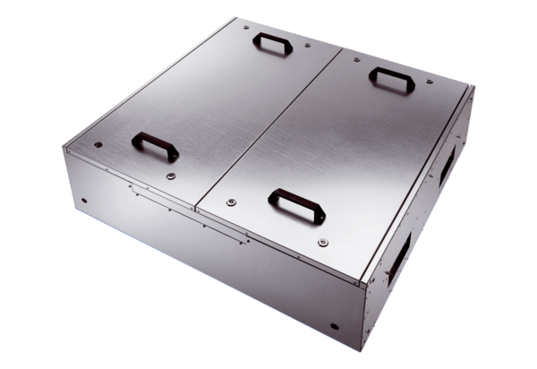Sound-insulated ventilation box KFR 6030-APacking unit: 1 pieceRange: K
Article number: 0080.0956Manufacturer: MAICO

