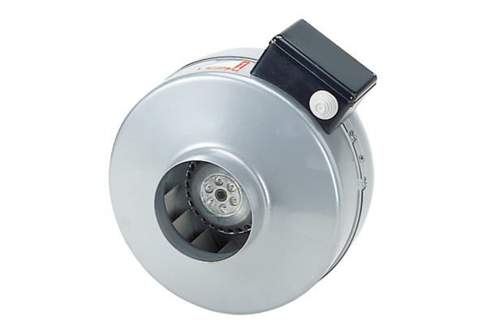Centrifugal duct fan ERR 10/1Packing unit: 1 pieceRange: C
Article number: 0080.0270Manufacturer: MAICO

