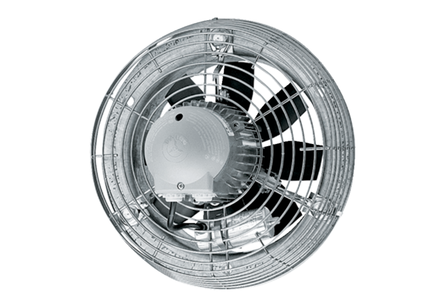Axial wall fan DZS 40/64 BPacking unit: 1 pieceRange: C
Article number: 0094.0050Manufacturer: MAICO

