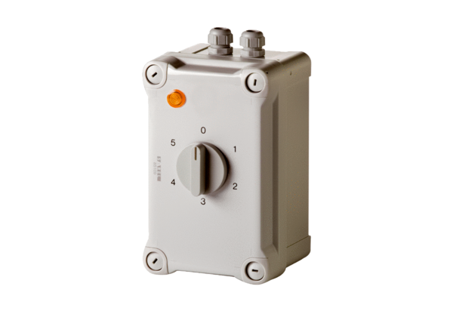5-step transformer TRE 0,4-1Packing unit: 1 pieceRange: C
Article number: 0157.0346Manufacturer: MAICO

