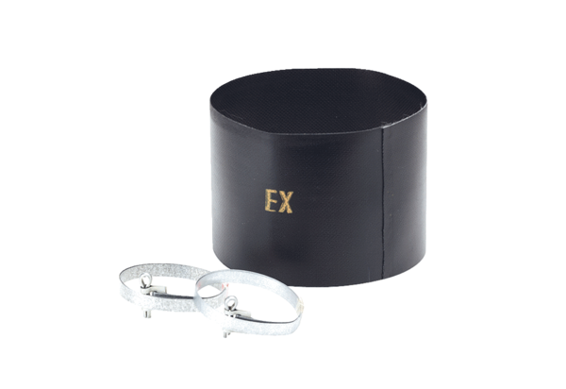Flexible cuff ELM 25 ExPacking unit: 1 pieceRange: C
Article number: 0092.0249Manufacturer: MAICO

