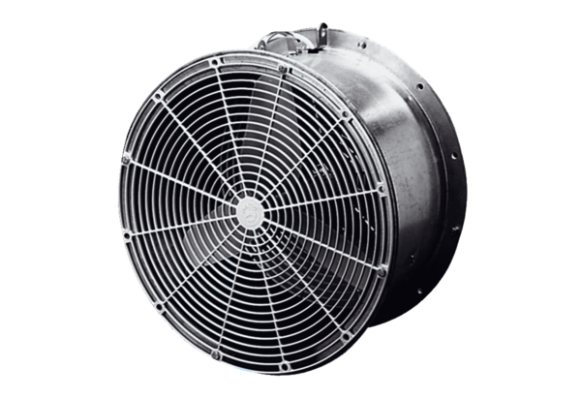Greenhouse fan EFG 25 EPacking unit: 1 pieceRange: C
Article number: 0081.0402Manufacturer: MAICO

