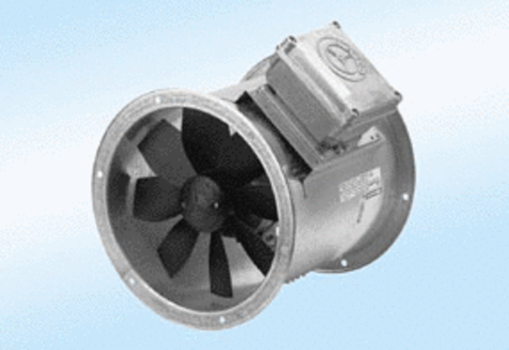Axial duct fan DZR 60/6 A-ExPacking unit: 1 pieceRange: C
Article number: 0086.0795Manufacturer: MAICO

