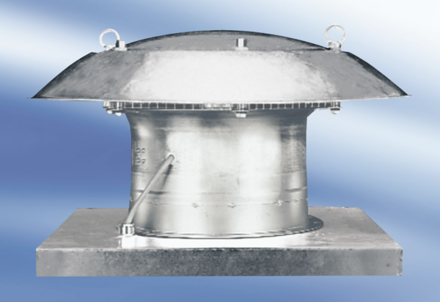Axial roof fan DZD 40/6 APacking unit: 1 pieceRange:
Article number: 0087.0421Manufacturer: MAICO

