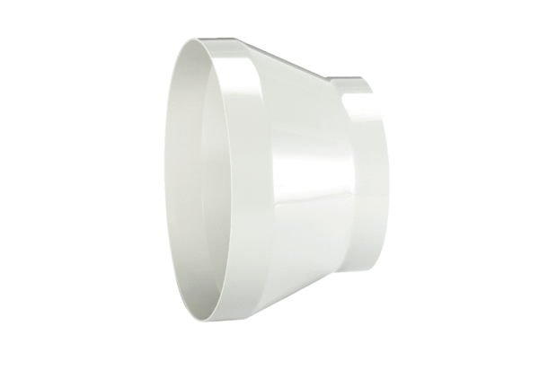Reducer REM 22/15Packing unit: 1 pieceRange: C
Article number: 0059.0635Manufacturer: MAICO

