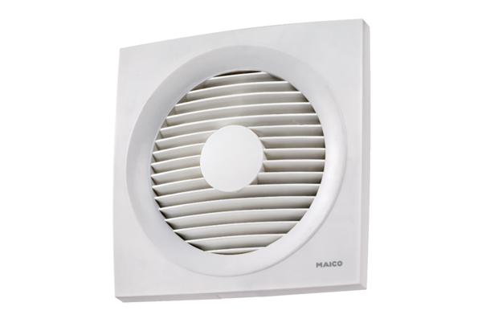Axial wall-mounted fan EN 31Packing unit: 1 pieceRange: C
Article number: 0081.0309Manufacturer: MAICO

