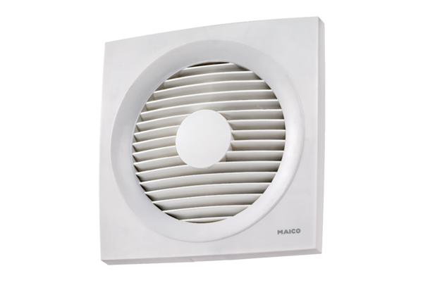Axial wall-mounted fan ENR 25Packing unit: 1 pieceRange: C
Article number: 0081.0317Manufacturer: MAICO

