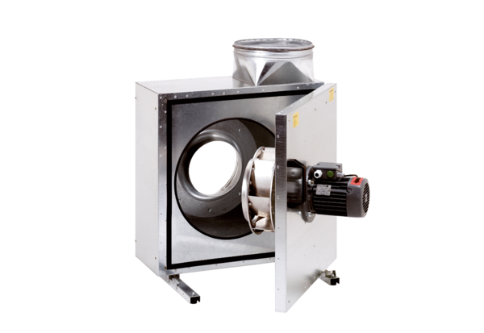Sound-insulated ventilation box EKR 20Packing unit: 1 pieceRange: C
Article number: 0080.0919Manufacturer: MAICO

