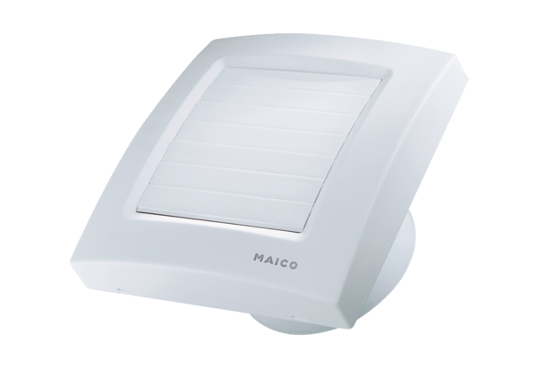Small room fan ECA 100 KFPacking unit: 1 pieceRange: A
Article number: 0084.0005Manufacturer: MAICO

